ITWorx

adges UI components library

Component ID #01 - Dynamic Footer - 0.1



# Document Control

## Version History

|  |  |  |  |
| --- | --- | --- | --- |
| **Version** | **Date** | **Author** | **Reason for Change** |
| 1.0.0 |  |  |  |
|  |  |  |  |
|  |  |  |  |
|  |  |  |  |
|  |  |  |  |
|  |  |  |  |
|  |  |  |  |
|  |  |  |  |

## Review History

|  |  |  |
| --- | --- | --- |
| **Version** | **Reviewer** | **Date** |
|  |  |  |
|  |  |  |
|  |  |  |
|  |  |  |
|  |  |  |
|  |  |  |
|  |  |  |

Table of Contents

Document Control 1

Version History 1

Review History 1

1. Document and components Purpose. 3
2. General Information. 3
3. How to use. 5
4. Component features and configure. 5
5. How to configure component. 6
6. Examples 6

# Document and components Purpose.

The purpose of the document is to guide how use and configure [Dynamic footer] component.

The purpose of the dynamic footer you can add any features or latest item on your site with emergency number block, fewer or one line nav links, multiple nav links with heading, the and you can configure the component based on your branding guideline.

# General Information.

Component Name: Dynamic Footer.

Extension Theme: ex-footer.

Owner: Manikandan.

Version no: v1.0

Design .

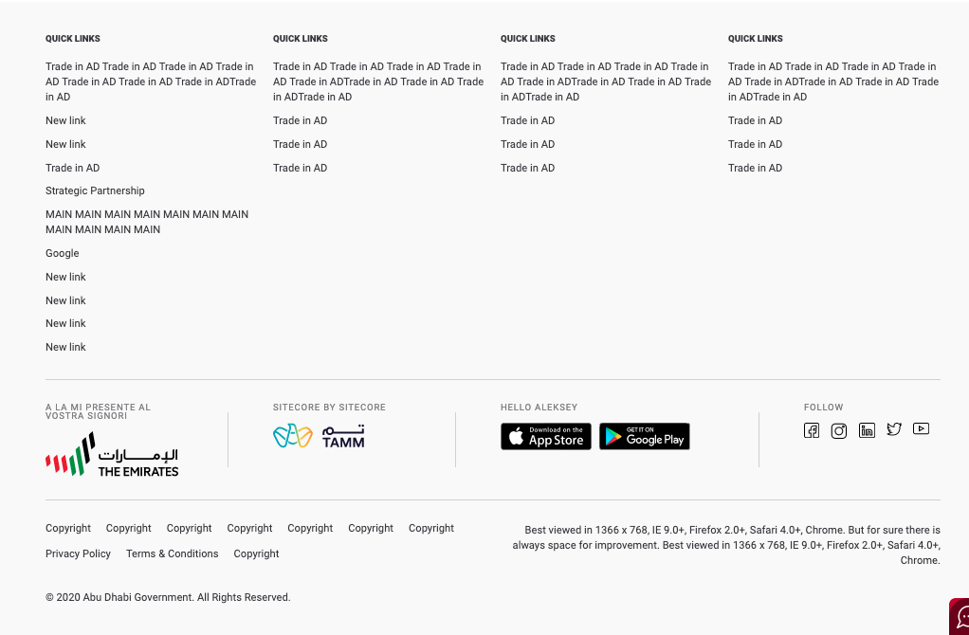



# How to use.

1. The available commands for this project .
   1. Compile : npm run gulp compile -- –path ex-footer –extension
   2. Compile & include under ADGE tenant : npm run gulp compile -- –path ex-footer –extension –full –dest [ADGEFolder]
   3. Deploy : npm run gulp deploy -- –path ex-footer –extension
2. *Now project have full copy from this extension theme under the project theme and you can apply the project brand guideline and configure component based on project needs.*

# Component features and configure.

You have access now to configure component with the below item.

$footer-multinav-bg: $grey-50 !default;

$footer-multinav-border-fg:$grey-200 !default;

$footer-multinav-item-selected-bg:$secondary-color !default;

$footer-multinav-item-color:$secondary-color !default;

$footer-multinav-item-selected-color:$white-color !default;

$footer-buttons-border: 1px solid $secondary-color !default;

$footer-settings-border-size:1px !default;

$footer-settings-anchor-fontsize:14px !default;

$footer-usefullinks-title-fontsize: 20px !default;

$footer-settings-title-fontsize : 12px !default ;

$footer-settings-title-color : $white-color !default;

$footer-copyrights-color : $grey-600 !default;

$footer-settings-anchor-copyrights-fontsize : 14px !default;

/* updated variable for footer logo */

$footer-poweredby-img-height : auto !default;

$footer-poweredby-img-maxwidth:none !default;

$footer-poweredby-img-width:auto !default;

$footer-poweredby-img-margin:0 2px !default;

$footer-poweredby-img-sep-color:$grey-800 !default;

$footer-poweredby-img-sep-height:auto !default;

$footer-poweredby-img-sep-width:1px !default;

$footer-poweredby-img-sep-maxwidth:1px !default;

$footer-poweredby-img-sep-margin:0 33px !default;

$footer-poweredby-span-color:$grey-700 !default;

$footer-poweredby-fontsize:11px !default;

/* end */

$footer-social-links-icon-width-height:30px !default;

$footer-social-links-ul-before-color:$grey-200 !default;

$footer-margin-li:25px !default;

$footer-strip-color:transparent !default;

$footer-strip-width:100% !default;

$footer-strip-height:9px !default;

$footer-links-hover-color : $primary-color3 !default;

$footer-usefullinks-title-font-weight : normal !default;

$footer-usefullinks-title-color: $black-color !default;

$footer-v2-black : $grey-900 !default;

$footer-v2-font-color : $grey-300 !default;

$footer-v2-link-hover-color : $primary-color3 !default;

$footer-v2-margin-li:40px !default;

$footer-v2-links-hover-border : 1px !default;

$footer-v2-usefullinks-lineheight: 20px !default;

$footer-v2-usefullinks-margin: 0 0 10px 0 !default;

$footer-v2-copyrights-li-margin-right: 20px !default;

$footer-v2-black-sep-color : color-opacity($white-color , 0.1) !default;

# Dependencies

components-Footer.css

components-Footer.js

# How to configure component.

There are various ways to configure the component:

1. **CSS Class / Data Configuration (on the variant)**

**CSS Class Configuration Method**

These styles can be applied in the variant to get the desired result

|  |  |  |
| --- | --- | --- |
| Feature | Modifier | Default value |
| Dark version | ex-footer—black |  |
| Smaller footer | ex-footer—compact |  |

1. **Adding Built-In or Bootstrap Class (on the variant)**
   1. Spaces, Font weights, Display, Position properties etc can be added by bootstrap classes
      1. i. Spacing: <https://getbootstrap.com/docs/4.0/utilities/spacing/>
      2. ii. Flex: <https://getbootstrap.com/docs/4.4/utilities/flex/>
      3. iii. Font: <https://getbootstrap.com/docs/4.0/content/typography/>
   2. These classes should only be added to match the design
   3. For built-in classes check 7 Below to see the entire list
2. **SCSS Variable Override (on the _override.scss file)**

To configure the component we can take the above variables from section **4. Component features and configure** and add them to: adge-ph2/themes/<ADGE>/vars/_override.scss, this file with your desired changes to match the design.

1. **Complete style override**
   1. This should be the last and final option if the above 3 didn’t get you the desired output
   2. This is overwriting the SCSS of the component by adding your own style to it
   3. **Note: Take permission before doing this override**
   4. Instructions:
      1. Open the file /adge-ph2/themes/<ADGE>/sass/overrides.scss and add your own SCSS styles to override the faulty component.

# Examples

-to change footer background

$footer-multinav-bg:$border-color !default;

-To change setting border color

$footer-multinav-border-fg:$grey-color2 !default;

-to change contrast hover and focus background

$footer-multinav-item-selected-bg:$secondary-color !default;

-to change contrast default color

$footer-multinav-item-color:$secondary-color !default;

-to change contrast default color

$footer-multinav-item-selected-color:$white-color !default;

-to change button footer border properties

$footer-buttons-border: 1px solid $secondary-color !default;

-to change footer border properties

$footer-settings-border-size:1px !default;

-to change anchor font size

$footer-settings-anchor-fontsize:14px !default;

-to change useful links font size

$footer-usefullinks-title-fontsize: 20px !default;

-to change footer strip color

$footer-strip-color:transparent !default;

-to change footer strip width

$footer-strip-width:100% !default;

-to change footer strip height

$footer-strip-height:9px !default;

-to change links hover color properties

$footer-links-hover-color : $primary-color !default;

-to change useful links title font weight

$footer-usefullinks-title-font-weight : normal !default;